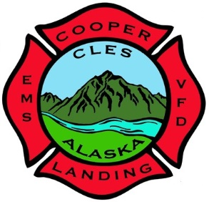**Cooper Landing Emergency Services**

**P.O. Box 510 - 38748 Snug Harbor Road**

**Cooper Landing, Alaska 99572**

**Phone & Fax: 907-595-1800**

**Application for** **Candidacy**

Cooper Landing Emergency Services Board of Directors

2024 General Election

**Introduction:**

To be elected as a Board Member, you must be a Corporate Member of CLES. Any natural person who is either a **resident, a property-owner or the owner of business** in the Cooper Landing zip code of 99572 and is at least 18 years of age qualifies for Corporation Membership. A resident is defined as a person who has maintained a principal place of abode in the 99572-zip code for at least 30 days before applying for Corporation Membership, and who continues to do so. No two members within a first degree of kinship may hold seats on the board at the same time. Nor may any two board members have a fiduciary or trustee relationship. “First degree of kinship" includes spouses, parents and their adopted and natural children, and siblings, and "fiduciary or trustee relationship" includes relationships such as those of employer/employee, student/teacher, benefactor/beneficiary, dependent/provider, or others where one party is objectively in a position to coerce the vote of the other party as a result of that relationship. The total seven (7) person board shall have no more than three (3) volunteers from the department in any form serving at one time.

Board Member Elections. To be considered for election to the Board of Directors, a Corporation Member shall complete this written application and submit to the Board Secretary at least **fourteen** days prior the date on which the vote will be held.

2024 Election: There are available: [ 2 ] Three Year Terms for Director, Seats A and B

Election Date: October 15, 3:30-5:30 - Cooper Landing Community Hall

**Applicant Information:**

Name:_______________________________

Cooper Landing Property, Mailing or Business Address: _____________________________________

Mailing Address (if different from above): ________________________________________________

Email:_______________________________ Phone:______________________

Affirmation of Candidacy:

I, _____________________, of the address(es) stated above, declare my candidacy for one of the following:

____ [ 3 ] Year Term on the Board of Directors for Cooper Landing Emergency Services.

I am___/am not___ a current volunteer with CLES. I am a member of the corporation and am otherwise qualified to serve. I understand that, if I am elected, I am subject to a background check for criminal and driving records only.

_____________________________ Date:________________

Signature of Candidate

***This declaration must be signed and received by CLES via*** [***operation.cles@arctic.net***](mailto:cles@arctic.net) ***– or- P.O. Box 510 Cooper Landing, Alaska 99572 on or before October 1, 2024***