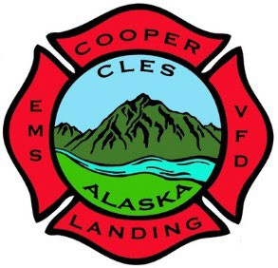
Cooper Landing Emergency Services
P.O. Box 510 - 38748 Snug Harbor Road Cooper Landing, Alaska 99572 Phone & Fax: 907-595-1800

Application for Corporation Membership
Cooper Landing Emergency Services

Introduction: Cooper Landing Emergency Services recognizes only one class of Corporate Membership. Qualifications and actions needed to become a Corporate Member are as follows: Any natural person who is either a resident, a property- owner or the owner of business in the Cooper Landing zip code of 99572 and is at least 18 years of age. To become a Corporate Member, a person shall submit this application. For purposes of the CLES Bylaws, a resident is defined
as a person who has maintained a principal place of abode in the 99572 zip code for at least 30 days before applying for Corporation Membership.

Corporate Members are entitled to voting in the CLES General Election for the Board of Directors and upon any corporate business action deemed necessary for voting by the membership. Corporate Members are not expected to participate in volunteer or responder capacities.

Corporate Members must maintain residency in the 99572 zip code in order to remain eligible for voting or holding office.

Applicant Information:
Name: Date of Birth:

Cooper Landing Property, Mailing or Business Address:

Mailing Address (if different from above):

Date Residency Established in Cooper Landing:

Email: Phone:

Affirmation Statement:
I, , of the address(es) stated above, have read the necessary information related to applying for Corporation Membership with Cooper Landing Emergency Services. I affirm the above is true to the best of my knowledge and ability in applying to the organization.

Date:

Signature of Applicant

